Research Report: Retaining College Graduates in Tallahassee

Retaining college graduates is key to a city’s growth and sense of place. The importance of young professionals’ contributions to economic mobility and entrepreneurial success cannot be overlooked. As a popular college town with three accredited universities, Tallahassee faces a unique challenge to attract graduates to live in the capital city after graduation. Tallahassee should combine its resources, career opportunities, and development plans with a priority of retaining recent graduates who experience a consistent pull toward bigger or busier urban cities.

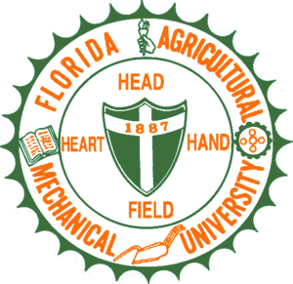
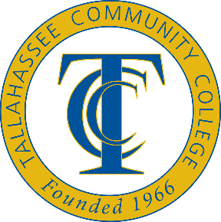
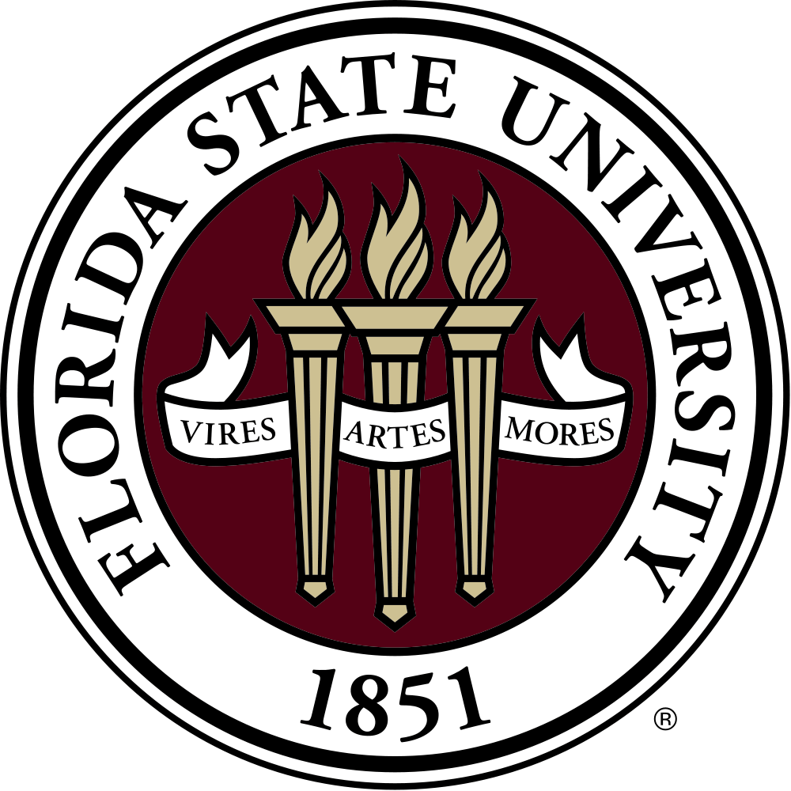

A 2009 Knight Foundation study found that only 1 in 4 graduates from Tallahassee’s three major colleges were still living in Tallahassee after graduating between 2004 to 2006. Graduates tended to choose to remain in Tallahassee either to join the local workforce (85%) or pursue further education (15%).

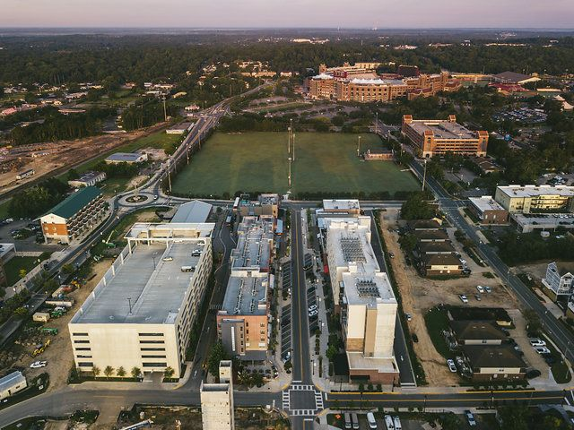
The Knight Foundation study also revealed that students frequently view Tallahassee as an exceptional place to be a college student, but highly disregard it as an exceptional place to live as a young professional. Students tend to be uninformed about local economic patterns, key employers, and local career opportunities. A common assumption made by recently graduated students was that Tallahassee does not offer as many professional opportunities as larger cities like Tampa, Miami, or Atlanta.

In response to this, a survey was created by Knight Creative Communities Institute’s intern on the Qualtrics research platform. It was open to FSU students from February 18 to April 18, 2020. The survey received input from 45 FSU students about placemaking and community aspects that would make them want to continue living in Tallahassee post-graduation. Participants were also asked about their interest in bicycling and a future Bicycle Park in Tallahassee.

Knight Creative Communities Institute (KCCI) is a local nonprofit dedicated to creating places and experiences that improve Tallahassee’s quality of life and community engagement. The survey was voluntary and took between 1-3 minutes to complete. Results will be used for planning future KCCI projects and enhancing Tallahassee’s livability with a focus on attracting recent local college graduates.

Survey Respondents

The survey was completed by 43 current undergraduate FSU students and 2 undergraduate TCC students. The majority of respondents have lived in Tallahassee for 3-4 years (42%), with a notable portion having lived in Tallahassee for 7 years or more (33%). All other respondents have lived in Tallahassee for less than a year (7%) or between 1-2 years (18%).

Findings: Satisfaction Living in Tallahassee

- Students were mostly neutral or disagreed when asked if they plan to stay in Tallahassee for at least 2 years after graduating (75%). Only 25% strongly or slightly agreed that they do plan to stay in Tallahassee.

- When asked to share some reasons why Tallahassee may not be an inviting city for young professionals, students responded with statements including:

- “The cost of living is high for what is offered, and there isn't enough of an entertainment scene. You have to drive to go to major concerts and events.”

- “Un-interesting downtown area, needs to have more townhomes and apartments that are not for students or senior citizens.

- “There is a lack of other college graduates staying here.”

- “There is not much for young people to do. The city is also very segregated and it’s hard to find diverse places here.”

- “I feel that other cities have more career opportunities and Tallahassee feels less diverse.”
- A majority of students slightly agreed (41%) or were neutral (21%) with the statement that they feel connected and involved in Tallahassee’s community.

Findings: Urban Spaces

- The most important factor for students (66%) to enjoy an urban space: Uses and activities, with multiple areas to relax, work, socialize, exercise, or create.
- Students revealed their favorite local urban spaces are Cascades Park (41.86%) and Collegetown (27.91%).

- Most students responded that Tallahassee should focus on community events and festivals (32%) and cultivation/promotion of arts and culture (27%) to attract young professionals.

Findings: Bicycling

- What do students wish Tallahassee had for more biking opportunities?

  - Improved bike-friendly roads (41%)

  - More spaces to bike recreationally (27%)

  - “I wish there were more bike trails within the city or downtown. I would even bike around a neighborhood if I lived in one.”
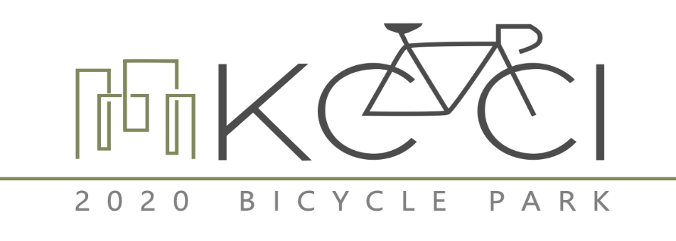

- When presented with 6 Bicycle Park designs, students rated the designs they would be most likely to use.

For each design, a question was asked on a scale from 1 to 5, with 1 being they would not attend the Bike Park and 5 being they would attend the Bike Park.
A second question was asked on a scale from 1 to 5, with 1 being the Bike Park would not benefit the community and 5 being the Bike Park would benefit the community.
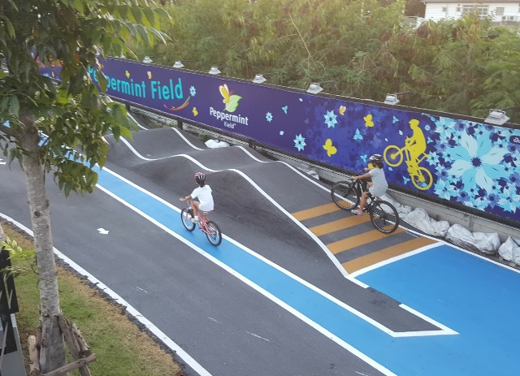

- Of the 6 designs, students responded most positively to this Bike Park. The average rating for likelihood of attending the park was 3.07, and the average rating for benefitting the community was 3.51.

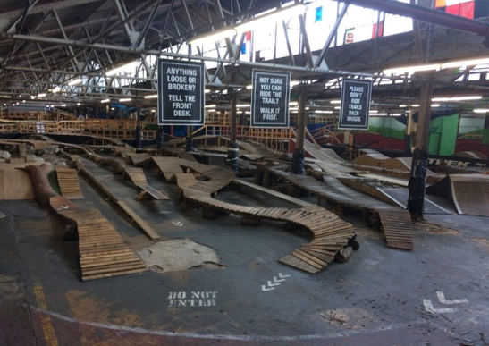

- Students rated this Bike Park design as their second favorite. The average rating for likelihood of attending the park was 2.67, and the average rating for benefitting the community was 2.97.

Conclusions and Recommendations

Based on the results of the study, several conclusions and recommendations can be drawn about the factors influencing recent Tallahassee college graduates’ living preferences. Key areas of improvement include enhancing Tallahassee’s entertainment venues, community events and festivals, and downtown experiences. Since students value multi-use urban spaces, future development and construction should take this into account.

Knight Creative Communities Institute and other local organizations can help retain young professionals and recent college graduates in Tallahassee through strategies including:

  - Organizing more public and affordable downtown concerts, festivals, and events
  - Using Cascades Park (most highly rated) as a model for future urban spaces
  - Prioritizing urban spaces with multiple areas to relax, work, socialize and create
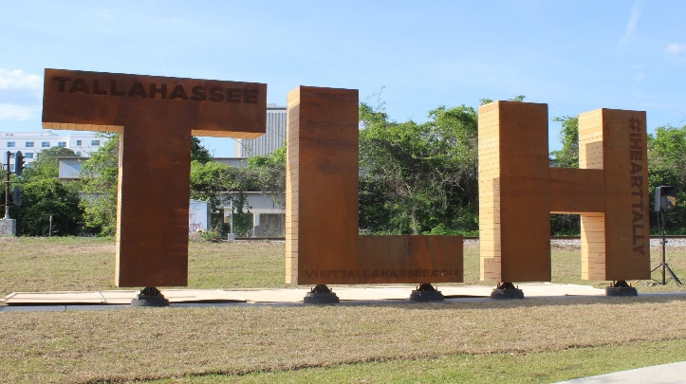
  - Including students in discussions about a local Bicycle Park
  - Leading efforts to improve bicycle lanes and trails accessible near the urban core

